Link between false PDL1 results and biopsy size

Intrinsic anomaly vs Adaptative expression (PDL1 expression is spatially and temporarily heterogeneous)
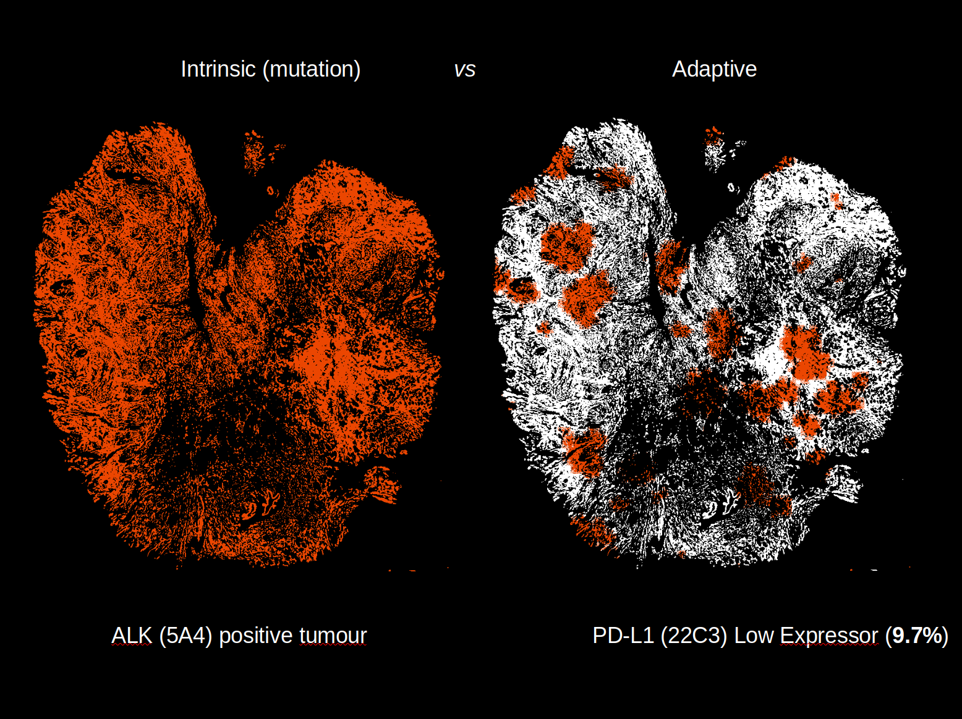

426 NSCLC Alberta 2017 Size Sample Histogram
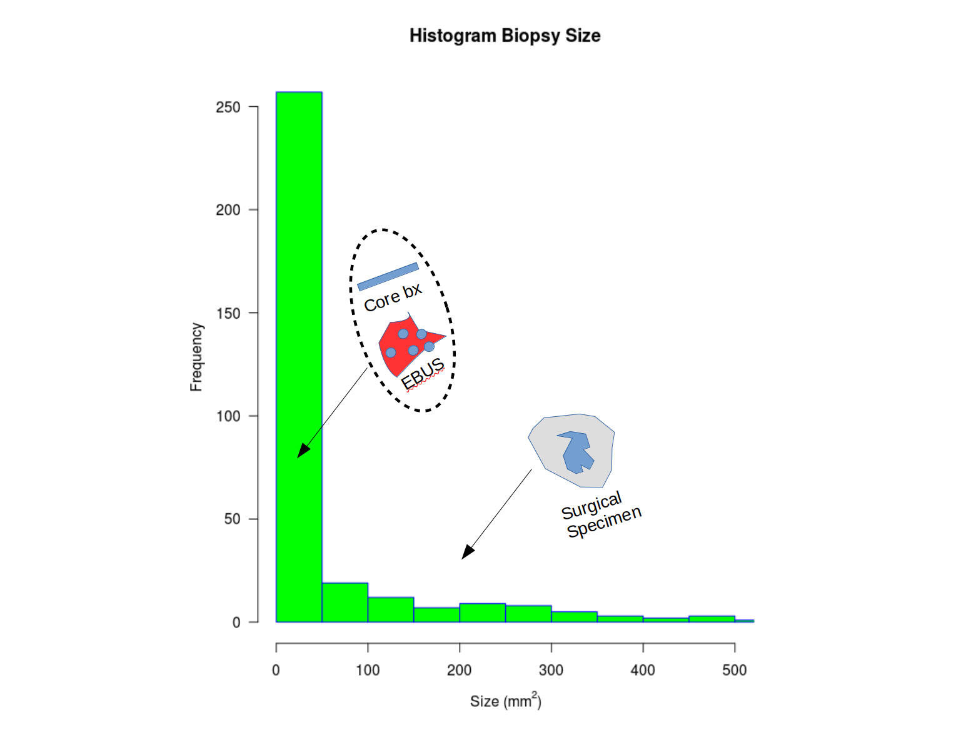

426 NSCLC Alberta 2017 Size Sample Histogram ZOOM on the smallest samples
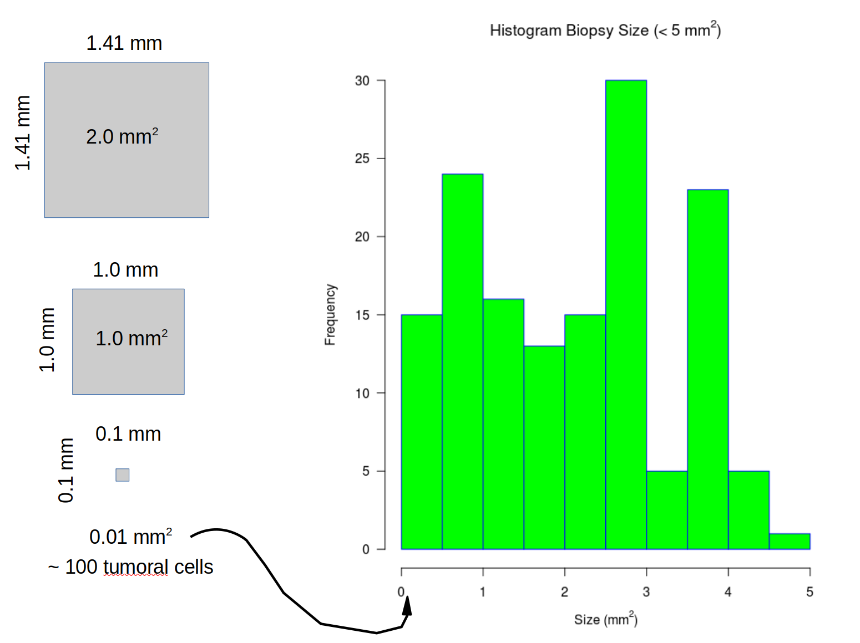

PDL1 results small vs large samples
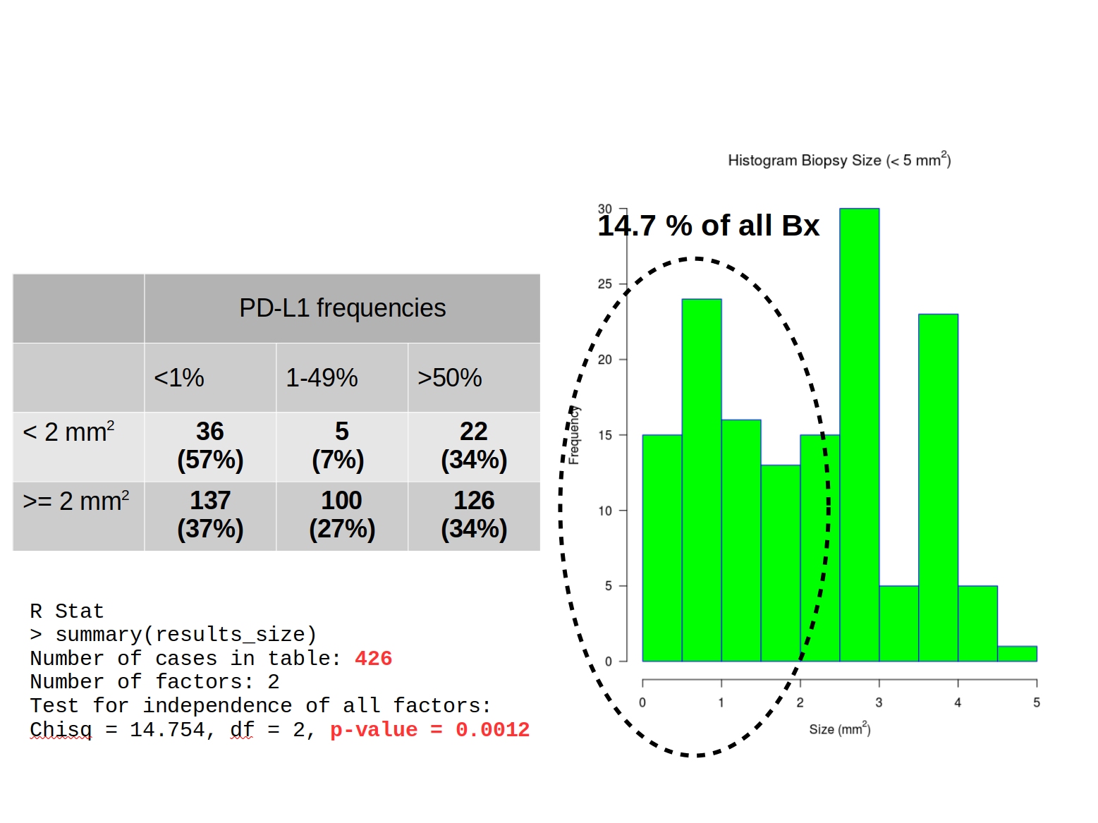

In silicon simulation (1/2)
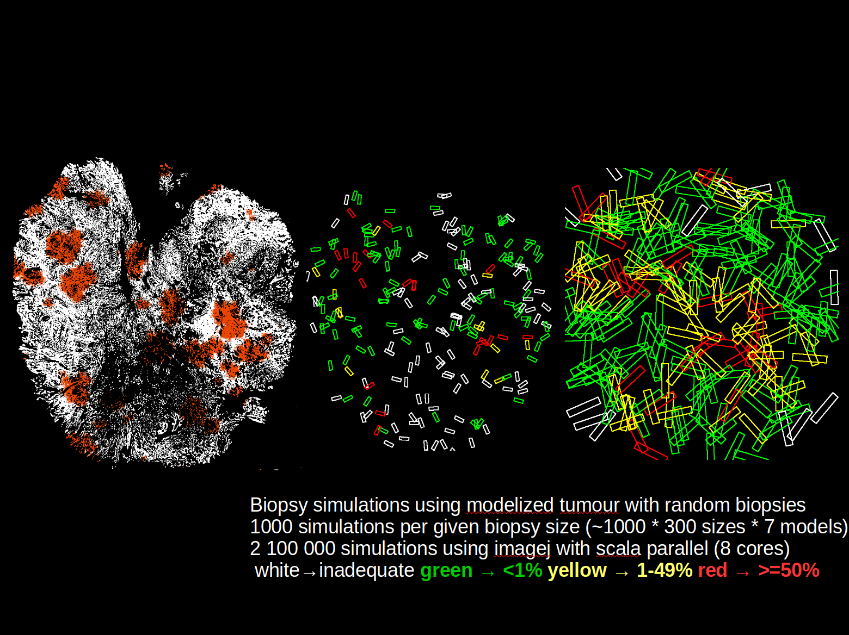

In silicon simulation (2/2)


