The 2015 KEYNOTE-001 clinical trial for the Treatment of NSCLC using Pembrolizumab
https://www.nejm.org/doi/full/10.1056/nejmoa1501824
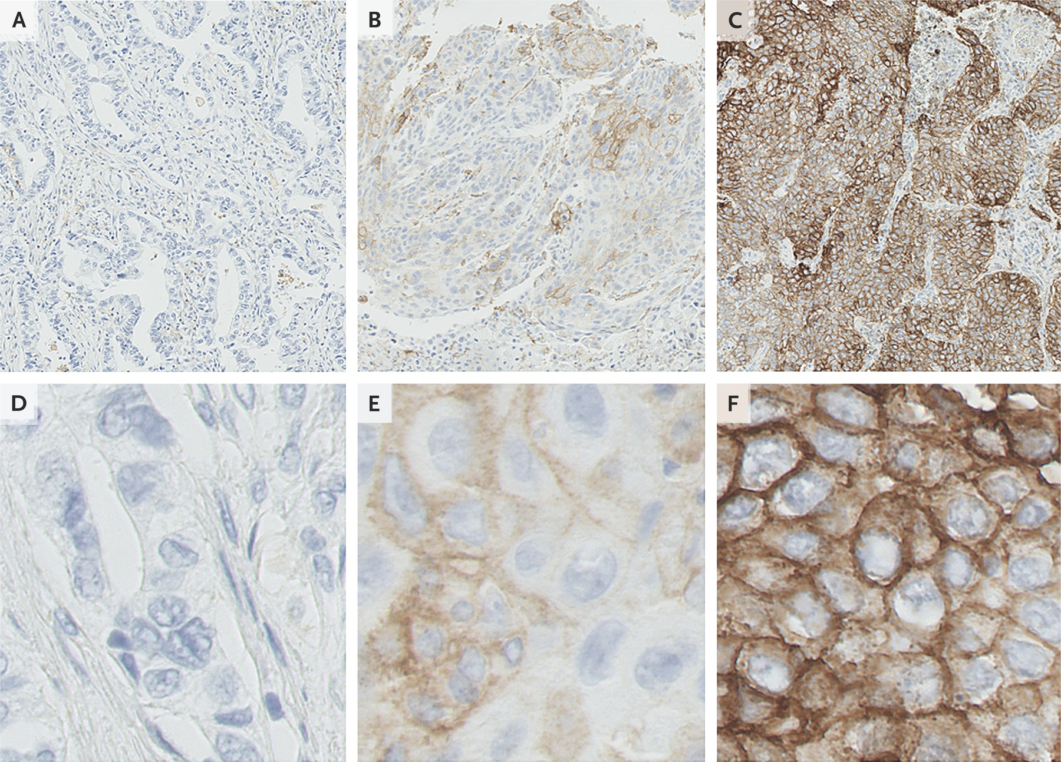
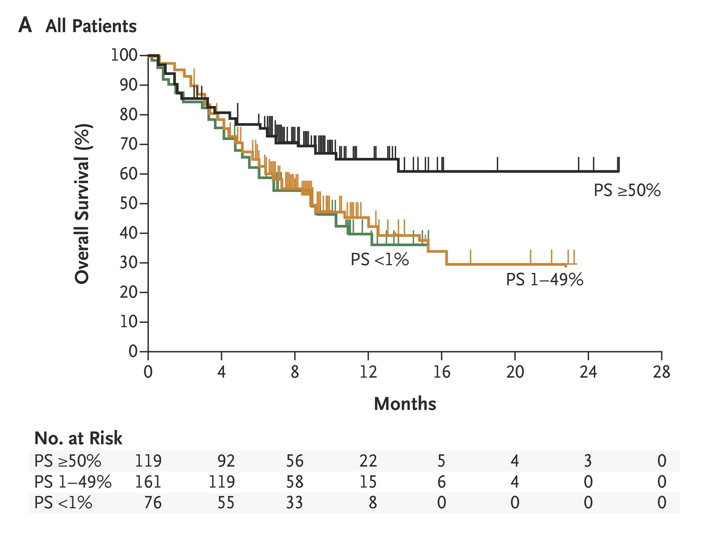


The 2015 KEYNOTE-001 Adverse Effects


